Assignment 2 - JavaScript Code
Q3.
1 | const http = require("http");
2
3 | const server = http.createServer((req, res) => {
4
5 | if (req.url === "/student") {
6 | res.writeHead(200, {
7 | "Content-Type": "application/json"
8 | });
9
10 | const student = {
11 | id: 101,
12 | name: "Zoro",
13 | course: "BTech in Computer Science",
14 | semester: 4,
15 | city: "Mumbai"
16 | };
17
18 | res.end(JSON.stringify(student));
19 | } else {
20 | res.writeHead(404, {
21 | "Content-Type": "text/plain"
22 | });
23
24 | res.end("404 - Page Not Found");
25 | }
26 | });
27
28 | server.listen(3000, () => {
29 | console.log("Server is running on http://localhost:3000");
30 | });

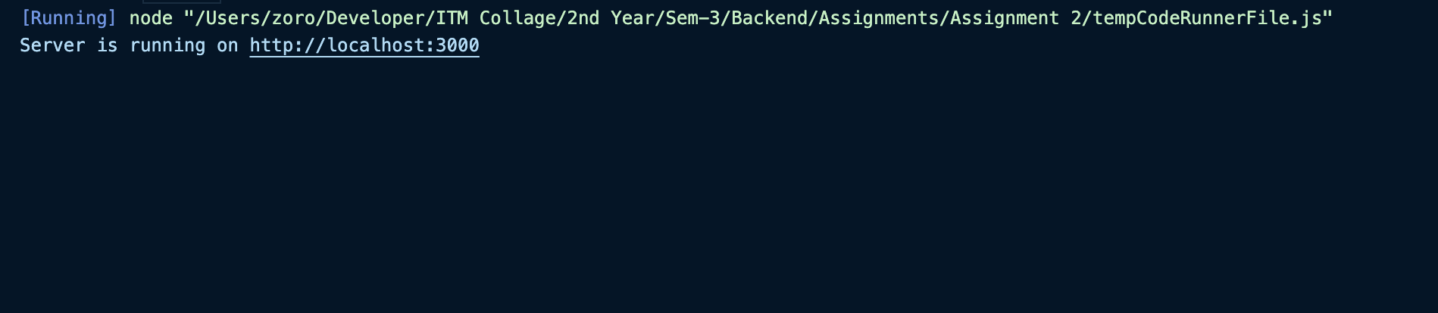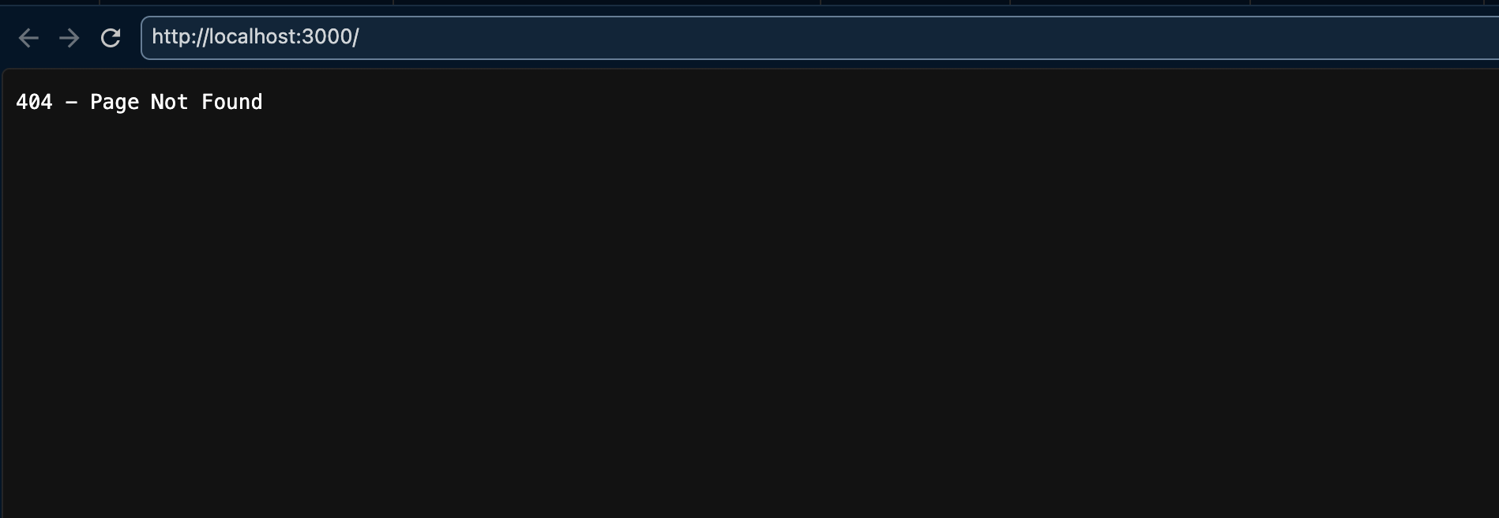

Q2.
1 | const http = require("http");
2
3 | const server = http.createServer((req, res) => {
4 | res.writeHead(200, {
5 | "Content-Type": "text/html"
6 | });
7
8 | const html = `
9 | <!DOCTYPE html>
10 | <html>
11 | <head>
12 | <title>Student Portal</title>
13 | </head>
14 | <body>
15 | <h1>Student Portal</h1>
16
17 | <hr>
18
19 | <p><strong>Name:</strong>Zoro</p>
20 | <p><strong>Course:</strong> BTech in Computer Science</p>
21 | <p><strong>College:</strong>ITM Skills</p>
22
23 | <p>Welcome to our Node.js application.</p>
24 | </body>
25 | </html>
26 | `;
27
28 | res.end(html);
29 | });
30
31 | server.listen(3000, () => {
32 | console.log("Server is running on http://localhost:3000");
33 | });

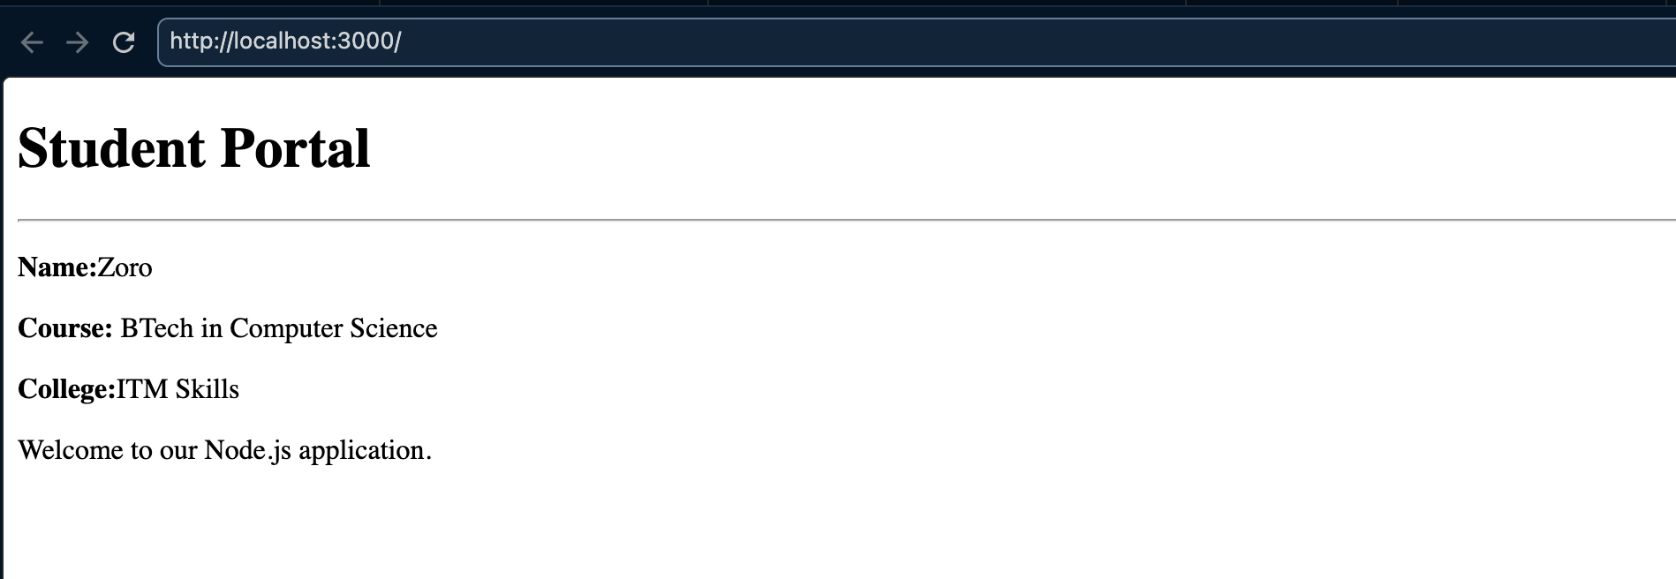

Q4.
1 | const http = require("http");
2
3 | const server = http.createServer((req, res) => {
4
5 | res.writeHead(200, {
6 | "Content-Type": "text/plain"
7 | });
8
9 | if (req.url === "/") {
10 | res.end("Welcome to Home Page");
11
12 | } else if (req.url === "/about") {
13 | res.end("About Us");
14
15 | } else if (req.url === "/contact") {
16 | res.end("Contact Information");
17
18 | } else if (req.url === "/services") {
19 | res.end("Our Services");
20
21 | } else {
22 | res.writeHead(404);
23 | res.end("404 - Page Not Found");
24 | }
25 | });
26
27 | server.listen(3000, () => {
28 | console.log("Server is running on http://localhost:3000");
29 | });

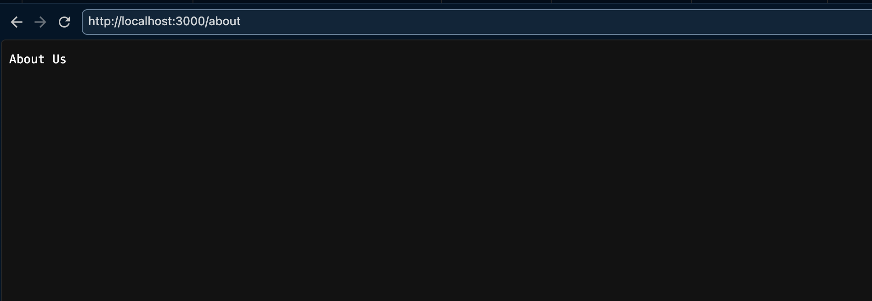
Q1.

1 | const http = require("http");
2
3 | const server = http.createServer((req, res) => {
4 | res.writeHead(200, {
5 | "Content-Type": "text/plain"
6 | });
7
8 | res.end("Welcome to Node.js Server");
9 | });
10
11 | server.listen(3000, () => {
12 | console.log("Server is running on http://localhost:3000");
13 | });

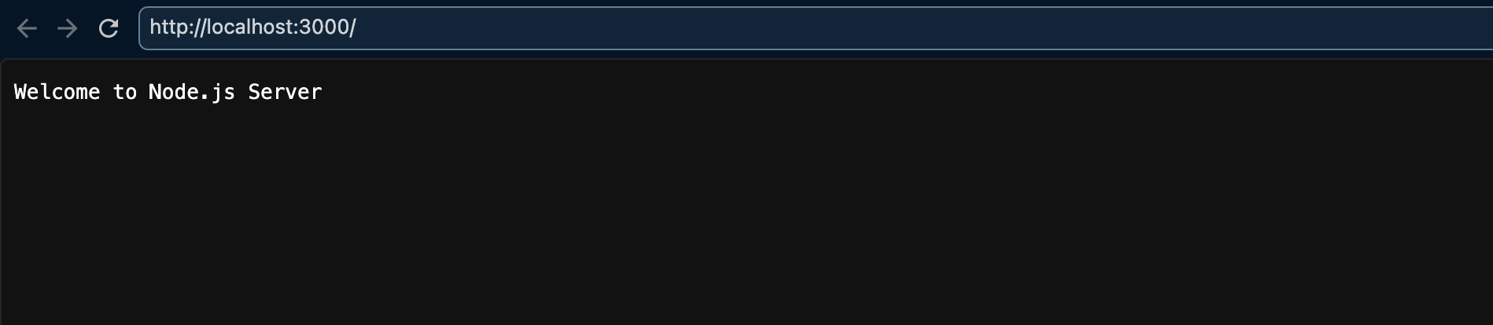

Q5.
1 | const http = require("http");
2
3 | const server = http.createServer((req, res) => {
4
5 | res.writeHead(200, {
6 | "Content-Type": "text/html"
7 | });
8
9 | let content = "";
10
11 | if (req.url === "/") {
12
13 | content = `
14 | <h1>Home</h1>
15 | <p>Welcome to my personal portfolio.</p>
16 | `;
17
18 | } else if (req.url === "/about") {
19
20 | content = `
21 | <h1>About Me</h1>
22 | <p>Hello! I am a student learning Full Stack Development and
 | Node.js.</p>
23 | `;
24
25 | } else if (req.url === "/skills") {
26
27 | content = `
28 | <h1>Skills</h1>
29 | <ul>
30 | <li>HTML</li>
31 | <li>CSS</li>
32 | <li>JavaScript</li>
33 | <li>Node.js</li>
34 | </ul>
35 | `;
36
37 | } else if (req.url === "/projects") {
38
39 | content = `
40 | <h1>Projects</h1>
41 | <ul>
42 | <li>Student Management System</li>
43 | <li>Portfolio Website</li>
44 | <li>Node.js HTTP Server</li>
45 | </ul>
46 | `;
47
48 | } else if (req.url === "/contact") {
49

50 | content = `
51 | <h1>Contact Details</h1>
52 | <p>Email: zoro@example.com</p>
53 | <p>Phone: +91 9876543210</p>
54 | `;
55
56 | } else {
57
58 | res.writeHead(404, {
59 | "Content-Type": "text/html"
60 | });
61
62 | res.end(`
63 | <h1>404 - Page Not Found</h1>
64 | <a href="/">Go Home</a>
65 | `);
66
67 | return;
68 | }
69
70 | const navigation = `
71 | <nav>
72 | <a href="/">Home</a> |
73 | <a href="/about">About Me</a> |
74 | <a href="/skills">Skills</a> |
75 | <a href="/projects">Projects</a> |
76 | <a href="/contact">Contact</a>
77 | </nav>
78
79 | <hr>
80 | `;
81
82 | const html = `
83 | <!DOCTYPE html>
84 | <html>
85 | <head>
86 | <title>My Portfolio</title>
87 | </head>
88
89 | <body>
90 | ${navigation}
91
92 | ${content}
93 | </body>
94 | </html>
95 | `;
96
97 | res.end(html);
98 | });
99
100 | server.listen(3000, () => {
101 | console.log("Server is running on http://localhost:3000");
102 | });
